Given the provided data, what are three conclusions we can draw about Kickstarter campaigns?

1. The category with the most campaigns overall is “theater”.
2. The sub-category with the most campaigns is by far “plays”, under the “theater” category.
3. December seems to be the only month where total failed campaigns outnumber the successful campaigns.

What are some limitations of this dataset?

* Data from countries outside the US are limited on Kickstarter.
  + The US has the most at 3038 entries, which forms a large gap with GB, who has the second-most data with 604 entries.
  + If other countries were to use Kickstarter campaigns more often, we could possibly observe a cultural difference (or lack thereof) in fundraising behaviors and categories.
* The “canceled” campaigns are difficult to interpret since they were likely cut short before their deadline; we’re unable to tell if they would’ve been successful or not.

What are some other possible tables and/or graphs that we could create?

* In the last PivotTable and PivotChart line graph, rather than sorting the data by months, we could sort them by years to observe how Kickstarter campaigns have changed in volume over time.
  + 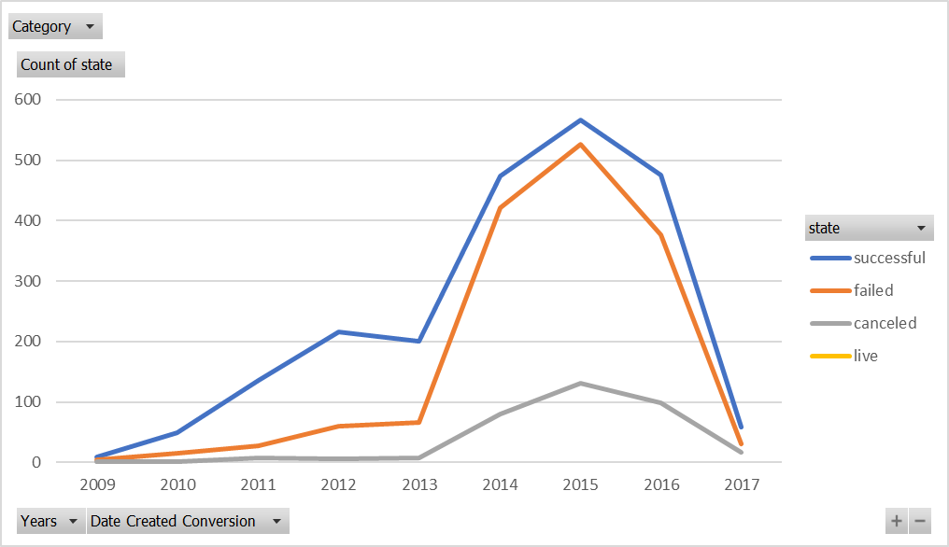
  + By doing so, we can observe that 2015 had a peak number of campaigns, though the ratio of “failed” to “successful” campaigns increased as well.
  + It may be due to “click fatigue,” a phenomenon where someone is less likely to click on a link and care about its contents if there’s exists an overwhelming number of links available.
* We can also compare average donations for successful campaigns depending on category and sub-category.
  + 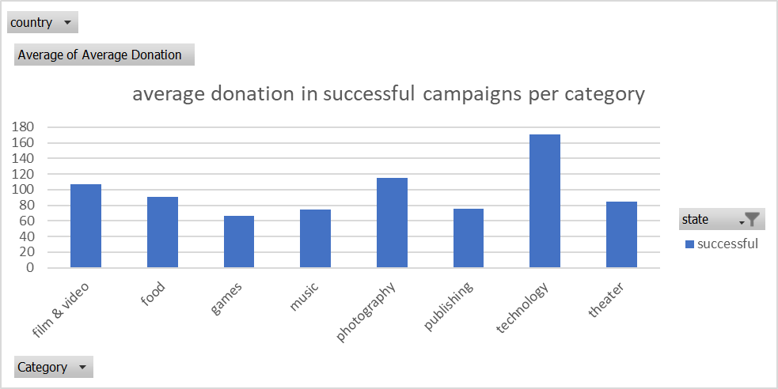
  + We can see that on average, the “technology” category received more money per backer, given that the campaign was successful, even though the “theater” category has the most successful campaigns.
  + 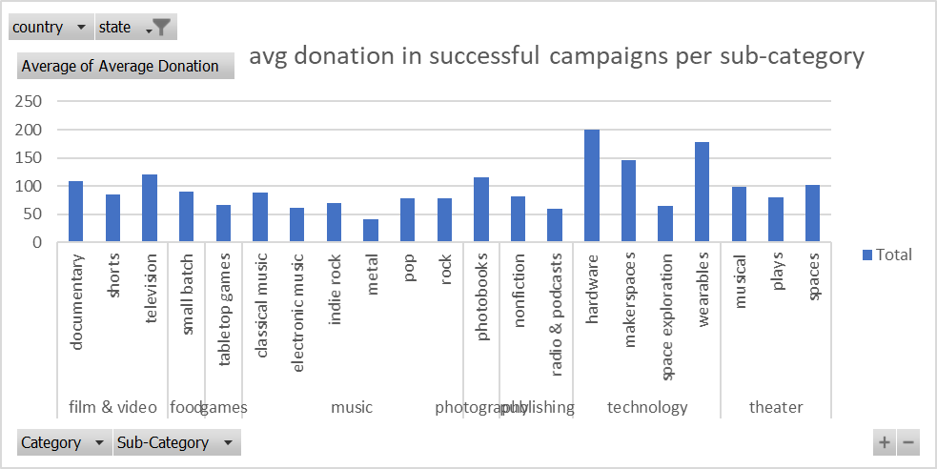
  + If we break it down further by sub-category, we can see that under technology, “hardware” and “wearables” have the highest average donation, which makes sense since these would likely be the most expensive to produce.